CUPE Local 5100
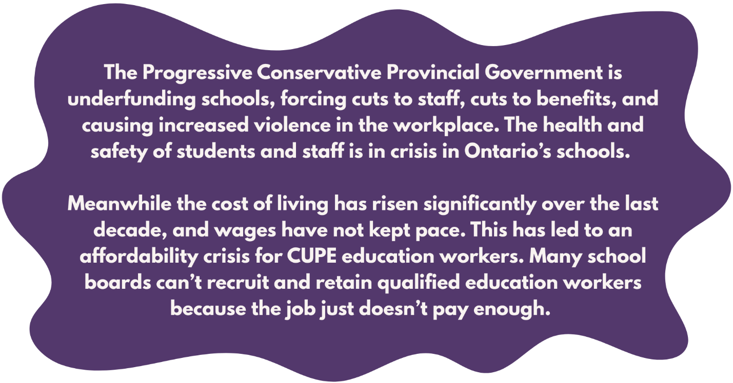
SIGN THE STRIKE PLEDGE!

Education workers deserve better.
Students deserve better.
CUPE education workers in all classifications across all school boards in Ontario are uniting to resist cuts and reclaim schools.
HAVE YOU SIGNED THE STRIKE PLEDGE?
Talk to your Site Communication Lead about signing the pledge to strike if necessary to win a contract that addresses the violence, understaffing and workload crisis in schools.
Contact Robin File-Sweers
Email: robin.filesweers@cupe5100.ca

Cell: 519-732-1028

